**Summary**

The CodeMR analysis of the project shows low to low-medium for all of the metrics it captured for our seven classes, with low-medium scores in complexity and size. The most complex classes were the Cat, Mouse, and Cheese classes. From the CodeMR website’s description of complexity (https://www.codemr.co.uk/features/) , it looks like these classes were listed as more complex due to the fact they all both reference each other and are referenced by the GameManager class. The code involved in the Cat and Mouse classes may have also been a factor, as both classes have logic to calculate their movements (with the Mouse class having its movement externally directed by the user through the UI). The largest class was the GameUI class, with 143 lines of code, giving it a size of low-medium. All classes had low coupling, as the classes did not constantly call or reference each other (though the project size definitely contributed to the low score). All classes also had a low lack of cohesion as all of them clearly fit together - making the code understandable, robust, and theoretically reliable (which it was, from my testing of the program).

**Output**

Distribution Graphs

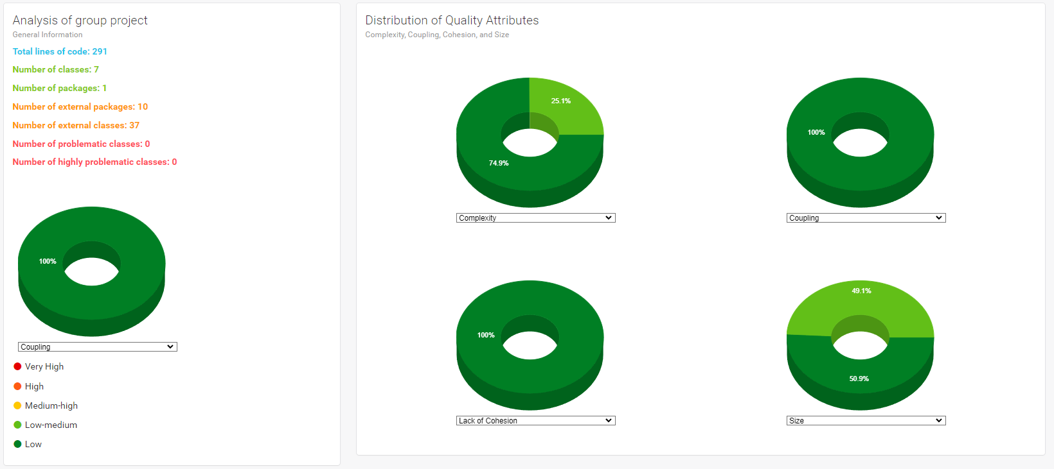

Detailed Metrics

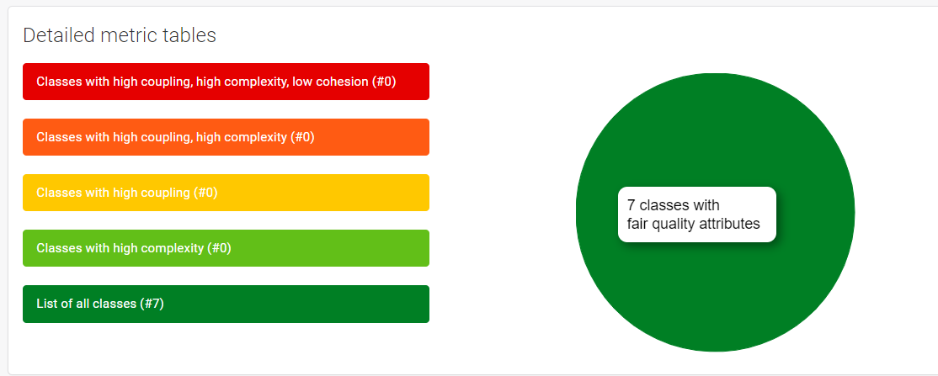

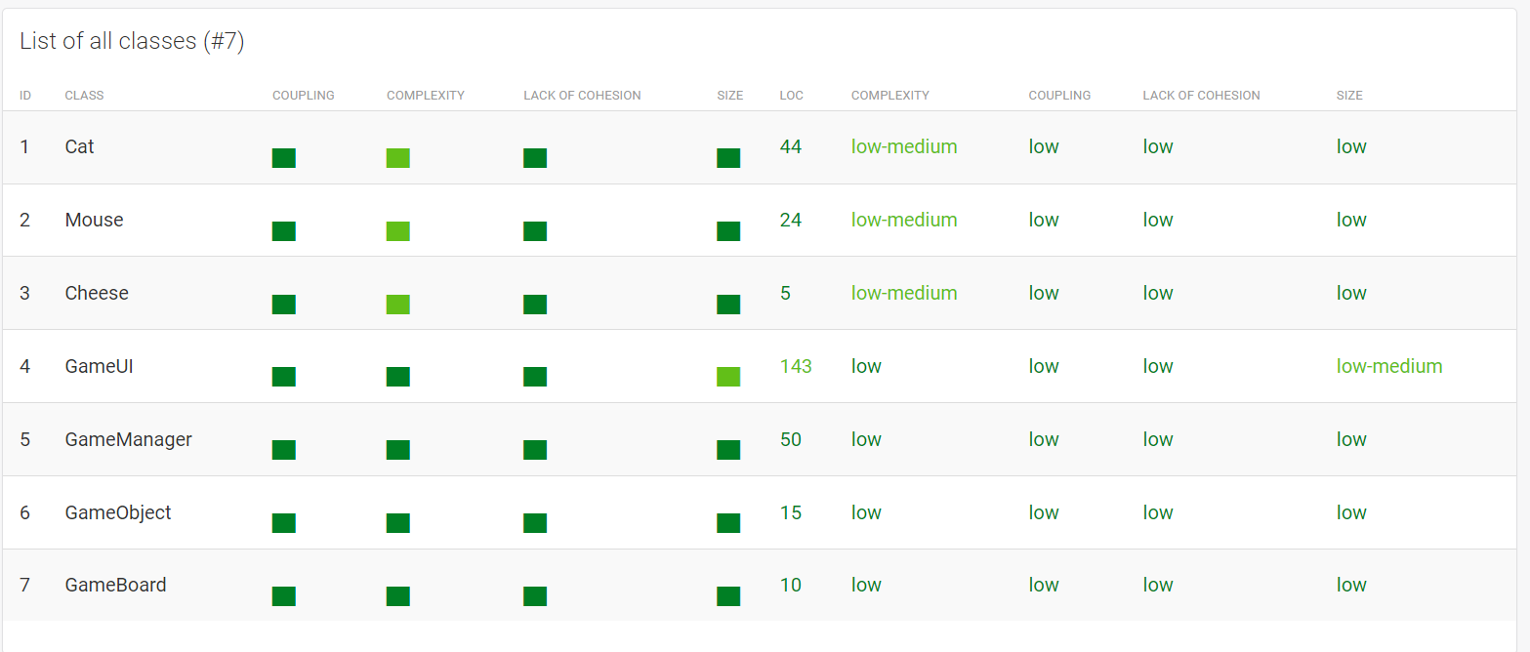

Modularity Graph

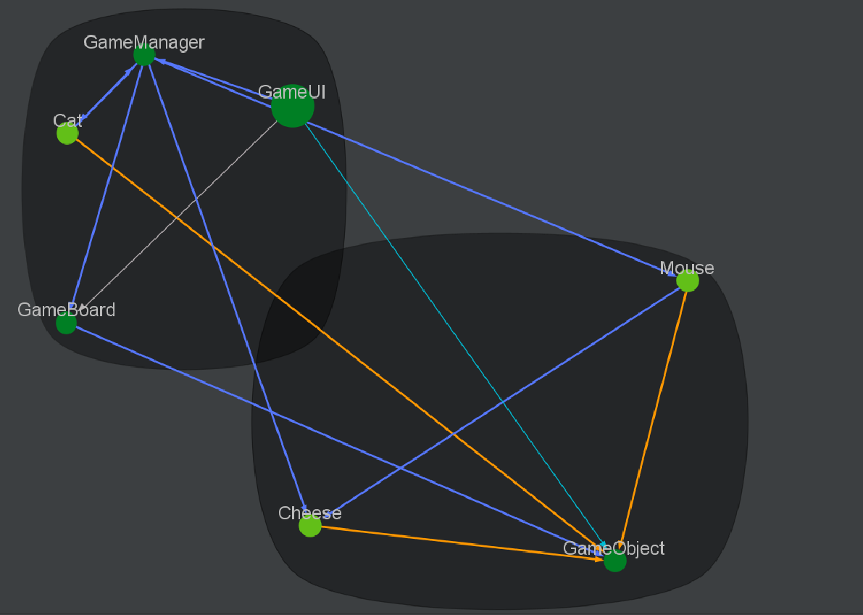

All inheritance

